Dear Editors
Under the ITLP category, I have attached our paper, ‘We just don’t sit there. We participate, interact and learn, and we rarely get bored – That is Lectorial’, and a signed copy of the authors’ statement.
We request that you may review this work for publication and hope that you find everything in order to do so.
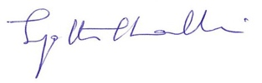
Kind Regards
Dr Jyothi Thalluri

